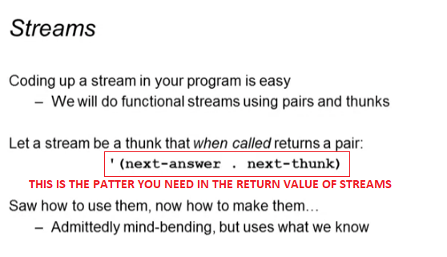

Infinite sequence of ones example

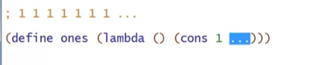

* Defining this way can literally take forever

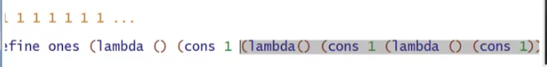

* But we already have something like this return value, and it is the **ones** function itself (CYCLIC RECURSION)

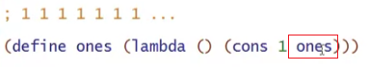

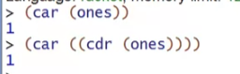

Stream of natural numbers

* 1,2,3,4,5…

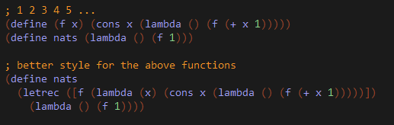





Stream of powers-of-two

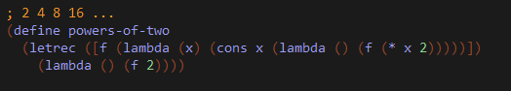

You can even abstract the streams

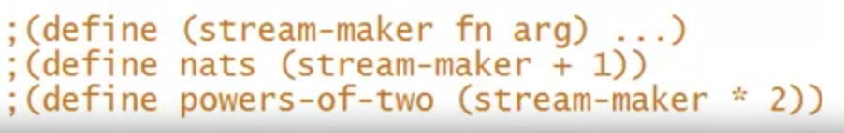

Some mistakes you can make

CORRECT PATTERN: **‘(next-answer . next-thunk)**

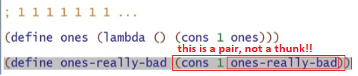

* It returns a pair not a thunk!
  + PATTERN: ‘(next-answer . pair)
  + This will evaluate ones-really-bad IMMEDIATELY

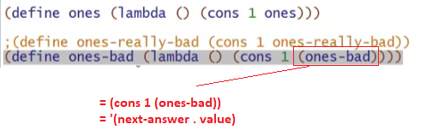

* Puts the result in the cdr not a thunk!
  + Infinite loop!
  + PATTERN: ‘(next-answer . value)